DAKOTAS CONFERENCE
2017 LICENSING AND LAY MINISTRY SCHOOL
Licensed Local Pastor Track
July 16-22, 2017
Living Waters Retreat Center UM Lake Poinsett Camp Arlington, SD

Registration: Sunday, July 16 from 3:00-3:45 p.m. We will conclude the school at 1:00 p.m. on Saturday, July 22.

Tuition (includes course fees, meals and lodging):

- *For those serving in the Dakotas Conference-$350
- For those serving in other Conferences-$650
Payable to:
Dakotas Annual Conference
Office of Leadership Development
PO Box 460
Mitchell, SD 57301
Prior to application approval, payments and registrations must be received no later than June 10th, 2017

*Scholarships are available for Dakotas Conference Members only. For more information, please contact Rev. Valerie Reinhiller (701-426-5456).

Dean: Rev. Valerie Reinhiller

Professors: Public Preaching, Worship and the Sacraments (and Faith Sharing) Dr. Ross Reinhiller

Pastoral Care for Spiritual Formation
Rev. Eric Van Meter

Educational Ministries in the Church
Rev. Valerie Reinhiller

Administration and Leadership
Dr. Gary Ball-Kilbourne

United Methodist Organization, History, Doctrine and Polity
Dr. Gary Ball-Kilbourne

Mission and Evangelism
Dr. Chet Cataldo

Introduction to Bible
Rev. Eric Van Meter

APPLICATION FOR LICENSED LOCAL PASTOR TRACK
2017 LICENSING AND LAY MINISTRY SCHOOL
DAKOTAS ANNUAL CONFERENCE
THE UNITED METHODIST CHURCH

Deadline: Applications and payments must be received by June 10, 2017

Demographic Information

Mr. Mrs. Ms.
(Please print name as it should appear on your certificate.)

Preferred name or nickname:

Male or Female:

Street Address or P.O Box

City, State, Zip

E-mail Address _Primary Phone

Date of Birth / /
Spouse’s Name_

Special Medical or Physical Needs

List any food restrictions

Emergency Contact Name and Phone Number_

Background Information

Highest Education Completed
(I.e. High School Graduate, Assoc. Degree, BS, MA, or years in seminary)

Present School

Present Employment

Role at Local Church or Current Appointment_

Name of Charge_

District Conference_

District Superintendent

Street Address or P.O. Box

City, State and Zip

Phone_ E-Mail

Date of Approval from SPRC/PPRC Chairperson

Recommended by Charge Conference (Date)

Written Application to District Superintendent (Y) (N) (Date)

Date of Certified Candidacy

Are you attending to be a Certified Lay Minister?

Your Signature Date_

Signature of District Superintendent Date_

Complete BOTH pages of application and mail the application and check to:

Dakotas Conference of the UMC
Leadership Development Office
PO Box 4 6 0
1331 University Drive
Mitchell, SD 57301
ATTN: Taya Swanson % Val Reinhiller
SCHOLARSHIP APPLICATION
2017 LICENSING AND LAY MINISTRY SCHOOL DAKOTAS ANNUAL CONFERENCE
THE UNITED METHODIST CHURCH

Deadline: Applications must be received by June 16, 2017

I would like to apply for the Dakotas Annual Conference $350 Scholarship to attend the 2017
Licensing and Lay Ministry School. (Only those from the Dakotas Conference are eligible to apply for this scholarship.)

Mr. Mrs. Ms.

Street Address or P.O Box

City, State, Zip

E-mail Address _Home Phone

Cell Phone_ Office Phone

Church Membership

Signature

Date

STUDIES FOR LICENSE AS a LOCAL PASTOR
IN THE DAKOTAS ANNUAL CONFERENCE OF THE UNITED METHODIST CHURCH
Referenced from the 2012 The United Methodist Book of Discipline

¶311-A certified candidate is eligible for appointment as a local pastor upon completion of License for Pastoral Ministry.

¶315-All persons not ordained as elders who are appointed to preach and conduct divine worship and perform the duties of pastor shall have a license for pastoral ministry. The Board of Ordained Ministry (¶635.2h) may recommend to the executive session of the annual conference the licensing of local pastors who have completed the following as noted in ¶315.

• The conditions for candidacy certification in ¶310.1-2;
• The studies for the license as a local pastor as prescribed and supervised by the Division of
Ordained Ministry or one-third of the M.Div. degree;
• Been examined and recommended by the district committee on ordained ministry;
• Released the required psychological reports, criminal background and credit checks, and
reports of sexual misconduct and/or child abuse.
• Provided the board with a satisfactory certification of good health on a prescribed form from a physician approved by that board.
• Been approved by the board of ordained ministry.

The granting of a license is an initial stage. The required period of 80 hours of study or equivalent does not give adequate preparation for any kind of parish work. A candidate granted license then must be prepared to continue in preparation for annual conference membership, either through college and seminary, or through the Course of Study schools. (¶319)

After the requirements of study are met, the faculty and/or administration of the school certifies completion of prescribed studies; the dCOM and BOM recommend the license; and the executive session of the annual conference approves the granting of the license. Award of the license shall not be made until an appointment to a pastoral charge is made in accordance with ¶337. (¶318)

The license is limited by three specific provisions:

1. Authority of the license extends only within the regular pastoral appointment or extension ministry made by the bishop—such authority does not extend within any other charge or setting.
2. Is under specific and direct supervision of the district superintendent and the mentor.
3. Is subject to annual renewal by the dCOM and BOM.

DIRECTIONS TO LIVING WATERS RETREAT CENTER AND LAKE POINSETT CAMP

©2012 Google - Map data ©2012 Google - A. Lake Poinsett Camp and Living
Waters Retreat Center
20 South Lake Drive, Arlington, SD (605) 983-5547
Google Maps Page 1 of 1 http://maps.google.com/maps?oe=UTF-8&ie=UTF8&q=living+waters+retreat+center+arli...
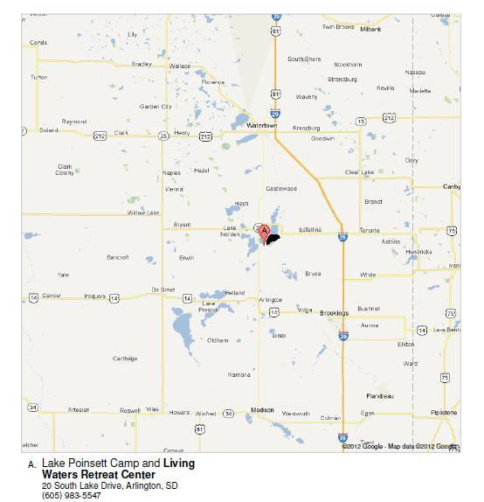
2/22/2012

Directions from Watertown, SD (from the east and north):

1. Turn onto US-81 S/5th St SE and continue to follow US-81 S for 24.9 mi.
2. Turn left onto 196th St/Co Rd 2/S Lake Dr. Continue to follow Co Rd 2/S Lake Dr. Destination will be on the left.

Directions from Brookings, SD (from the east and south):

1. Turn onto US-14 W/6th St. Continue to follow US-14 W for 1.9 mi.
2. Turn right onto US-14 W/W 18th St/211th St. Continue to follow US-14 W for 17.3 mi.
3. Turn right onto US-81 N/454th Ave. Continue on US-81 N for 12.5 mi.
4. Turn right onto 196th St/Co Rd 2/S Lake Dr. Continue to follow Co Rd 2/S Lake Dr. Destination will be on the left.

Directions from Rapid City, SD (from the west and south):

1. Follow I-90 E past Mitchell, SD.
2. Take Exit 365 onto US-81 N. Continue on US-81 N past Arlington, SD.
3. Turn right onto 196th St/Co Rd 2/S Lake Dr. Continue to follow Co Rd 2/S Lake Dr. Destination
will be on the left.

Directions from Bismarck, ND (from the west and north):

1. Follow I-94 E to Fargo, ND and take ramp onto I-29 S.
2. Continue on I-29 S until Watertown, SD. Take Exit 177 onto US-212 West.
3. Follow US-212 West through town.
4. Turn left onto US-81 S/5th St SE and continue to follow US-81 S for 24.9 mi.
5. Turn left onto 196th St/Co Rd 2/S Lake Dr. Continue to follow Co Rd 2/S Lake Dr. Destination will be on the left.

