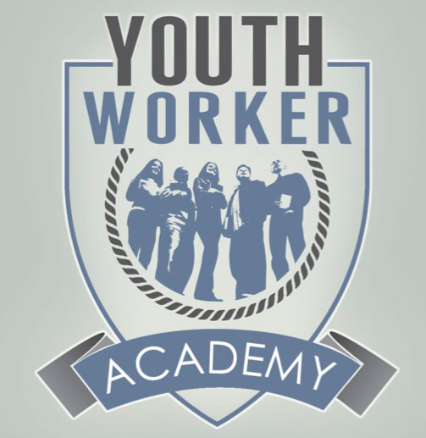

2017 Keynote Presenter: Kenda Creasy Dean
Kenda is an ordained elder in the Baltimore-Washington Annual Conference (United Methodist) and professor of youth, church, and culture at Princeton Theological Seminary, where she works closely with the Institute for Youth Ministry. A graduate of Wesley Theological Seminary, she served as pastor in suburban Washington DC and as a campus minister at the University of Maryland-College Park before coming to Princeton Seminary. She is currently appointed as the coordinating pastor of Kingston United Methodist Church in Kingston, New Jersey.

Major Publications-
The Theological Turn in Youth Ministry with Andrew Root (InterVarsity, 2011)
OMG: A Youth Ministry Handbook (Abingdon Press, 2010)
Almost Christian: What the Faith of Our Teenagers is Telling the American Church (Oxford University Press, Oxford University Press, 2010)
Youth, Religion, and Globalization, New Research in Practical Theology, eds. Richard R. Osmer and Kenda Creasy Dean (Zurich: LIT Verlag GmbH Co., 2007)
Practicing Passion: Youth and the Quest for a Passionate Church (Wm. B. Eerdmans Publishing Company, 2004)
Starting Right: Thinking Theologically about Youth Ministry (Youth Specialties Academic/Zondervan, 2001)
The Godbearing Life: The Art of Soul-Tending for Youth Ministry (Upper Room, 1998)

2017 Youthworker Academy Schedule-
FRIDAY:
6:30-7:30pm Registration at LPC
7:30-9pm Meet and Greet/Session 1

SATURDAY:
8:30am Breakfast
9:30am Session 2
12pm Lunch
1pm Session 3
3:30pm Session 4
5:30pm Dinner
7pm Q and A with Kenda
9:30pm Worship

SUNDAY:
8:30am Breakfast
9:30am Closing Worship
10:30am Head Home

