Then the righteous cry out, the Lord listens; he delivers them from all their troubles. Psalm 34:17
Our neighbors in Florida, Texas, Puerto Rico and beyond are crying out. God calls us to action. We will dedicate our annual Dakotas Conference Thanksgiving Offering to United Methodist Committee on Relief (UMCOR) recovery efforts. — Bishop Bruce R. Ough

In the Dakotas, we know something about flooding and the devastation that results. We have experienced massive flooding of the Red River. We know what it is like to cry out for the Lord in despair. We also know how the Lord answered our prayers, by sending us hundreds of volunteers and more than $500,000 to rebuild.
Hurricane Maria
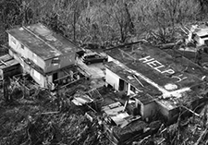
The need is huge. Hurricane Maria left behind catastrophic destruction. Authorities have announced that restoration of power alone could take more than six months. So far, only 7% of Puerto Rico's power has been restored. People are without communication and transportation.

UMCOR is on the ground. A food pantry at San Pablo Methodist Church has serves some 5,000 meals to the community, each day. Donations to UMCOR help buy needed supplies, including water, food, batteries, solar light bulbs and radios.

Hurricane Irma

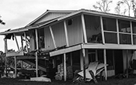
The storm, which made landfall in Florida as a Category 4 Hurricane, has claimed the lives of at least seven people on the U.S. mainland and 37 people in the Caribbean. It will be a five-year recovery process for Irma.

The state governments and FEMA will focus on higher population areas. UMCOR and conference disaster response teams will go to areas where nobody wants to work.

Hurricane Harvey

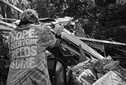
Tropical Storm Harvey’s devastation of Houston has captured the world’s attention, but smaller cities and towns to the east and southeast in Texas have been hit just as hard, and flooding rains began to reach Louisiana.

Recovery teams are mucking out homes and rebuilding. Donations are requested at this time for supplies and support of the recovery efforts. When you give to UMCOR, 100 percent of what is given will help to those who have been hard hit.

I boldly ask you to receive a Thanksgiving offering to continue our relief and recovery efforts. —Bishop Ough

