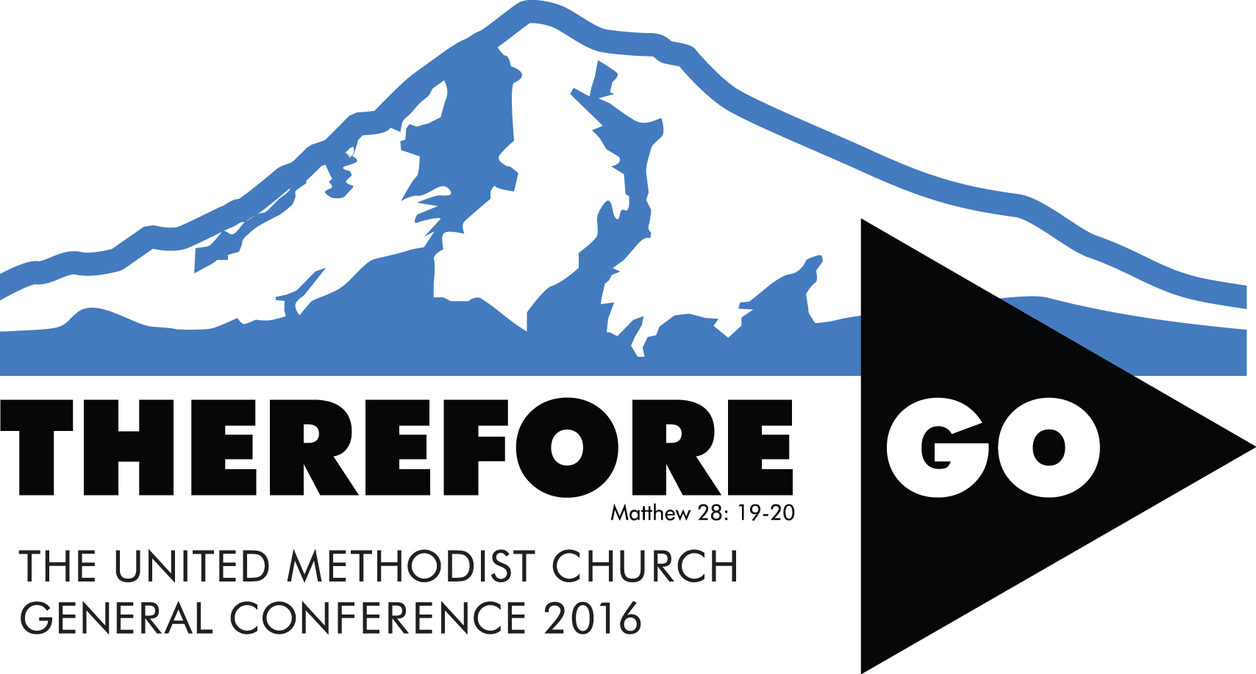
Our church to join other Dakotas United Methodists in prayer on March 24, 2016

General Conference—the top policy-making body of The United Methodist Church—will convene May 10-20, 2016 in Portland, Oregon. Two delegates from the Dakotas will join other United Methodists from around the world in making decisions that impact our denomination. Every annual conference has been invited to host a 24-hour prayer vigil in the months leading up to General Conference. Dakotas churches have committed to praying on March 24, and our church has signed up for ________ to ________ on that day. Please join us in prayer at that time.

General Conference 2016 Sample Prayer for Vigil:

Almighty and gracious God, as we prepare for General Conference in Portland, have mercy on your church, troubled and divided. Pour out your heavenly blessings; redeem, restore and remold your church until we are made new, that we may be one in Christ for the sake of the world. Instill within delegates humble hearts and discerning minds that hunger and thirst for your righteousness and justice, and your vision for our future. Through the decisions and spirit of General Conference, renew in the whole church a passionate longing for the coming of your kingdom, and unite us in one mission: to reach and make new disciples of Jesus for the transformation of the world. Amen.

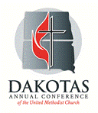
P.O. Box 460
1331 University Ave.
Mitchell, S.D. 57301-0460
www.dakotasumc.org

