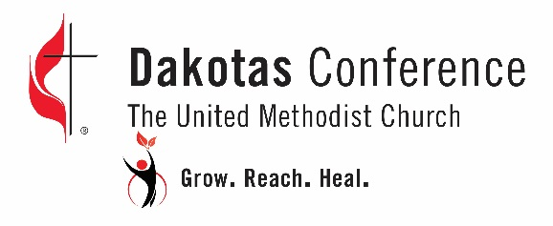
Young Adult and Campus Ministries Grant Application
Vision—For every congregation to become a vital expression of the scriptural imperatives of: grow in love of God and neighbor, reach new people, and heal a broken world.

Name of program:
Please describe the program and why the program is important to your church:
What is the impact of this program?
List the goals for the program (include timeline for implementation):
List the name(s) and role(s) of the leader(s) for this program:
How does the program call forth persons with gifts to become bold spiritual leaders?
How does the program create disciples for Jesus Christ for the transformation of the world?
How does the program connect with the Dakotas Conference vision?
What evidence will indicate the program is fruit-bearing (be specific)?
Program location:
Budget:
Other sources of funds:
Amount requested (requests cannot be larger than $10,000):
If application is not accepted, will the program continue?
Does the church to which you are connected pay full apportionments? ____ yes ____ no
*contact your church treasurer or the Dakotas Conference Finance office for information as needed.

Please describe your plans to become fully financially self-sustainable in three years’ time:
Other relevant information:

Contact information

Name of person submitting application: Primary Phone:
Email address:
Mailing address:

Application Process

Please submit your application by November 1st, to the office of Leadership Development by email to taya.swanson@dakotasumc.org or by postal mail to Leadership Development, Dakotas Conference UMC, PO Box 460, Mitchell, SD 57301. Use as much space as needed to reply to each item. Applications will be reviewed by the Missional Leaders Link.

